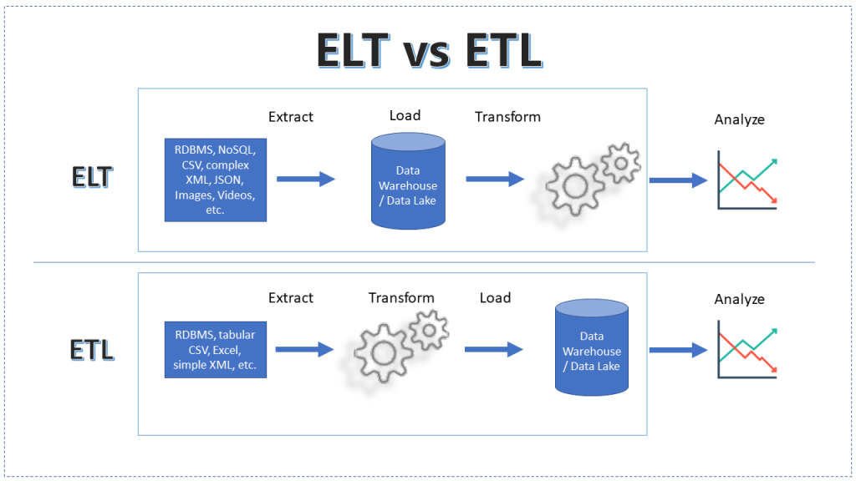

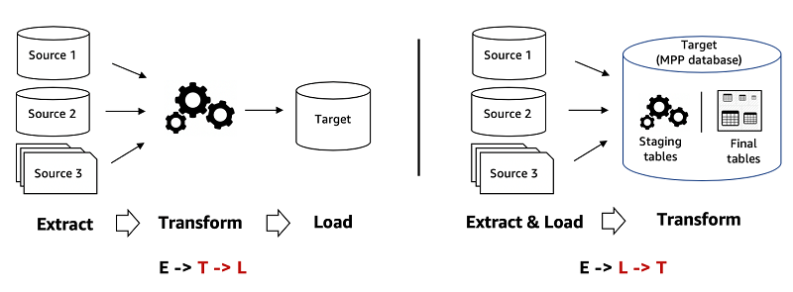

Feature | ETL(Extract-Transform-Load) | ELT(Extract-Load-Transform)
Transformation | Performed before Loading (Datawarehouse) | Performed after Loading (Data Lake / Lakehouse / Cloud Warehouse)
Data Storage | Stores only processed data/clean data | Stores raw data first
Processing Power | Uses External ETL Tools | Uses Cloud based warehouses
Speed | Slower due to preloading transformation | Faster data ingestion
Best for | Structured, on-premises data warehouses | Cloud-based analytics and bigdata
Example tools | Informatica, Talend, Apache Nifi, SSIS, AWS Glue, Azure Data Factory (Both ETL and ELT), Google Cloud Dataflow, AWS Data Pipeline | Snowflake, Bigquery, AWS Redshift, Azure Synapse, Azure Databricks, Azure Data Factory (Both ETL and ELT)
Use Cases | Banking, Healthcare | IoT (Smart Cities), social media

